**2025 PHOTOGRAPHY – DIVISION 4004**

*Daviess County Fair is not responsible for lost or damaged entries.*

**GENERAL RULES**

1. All entries must be entered at the Exhibit Building on **Tuesday of fair week** from **4:00 – 7:00 p.m.** Entries and **premiums** may be picked up from **1:30 – 3:00 p.m., Sunday after the fair.**
2. Any single photo print up to 16” x 20” is permitted and must be mounted proportionately and securely to mat board or foam core board. The board can not be larger than 16” x 20”. A square photo may be mounted and matted on any 16” square or smaller. No collages are allowed.
3. The thickness of the entry must not be greater than ½ inch.
4. Print your name on the back of the entry. Do not put your name on the front of the entry itself. *If you do not wish to reclaim your entry after the fair closes, write “recycle” on the back of the entry.*
5. The following is PROHIBITED: Glass coverings, frames, wires, clips, strings, thin poster board, Masonite, or any sticky substances felt on any part of the front or back of any entry.
6. All correctly tagged entries are pre-screened upon check-in by volunteers, handled by runners, and immediately displayed by volunteers and staff according to the class # entry tag.
7. Entries not meeting the stated specifications will be immediately returned to the exhibitor upon disqualification at the check-in table.
8. Hand-tinted images or monochrome images that have been digitally manipulated to show a specific color (such as a red dress in a black & white print) must be entered in the color classes.

**Best Entry – $25 & Rosette**

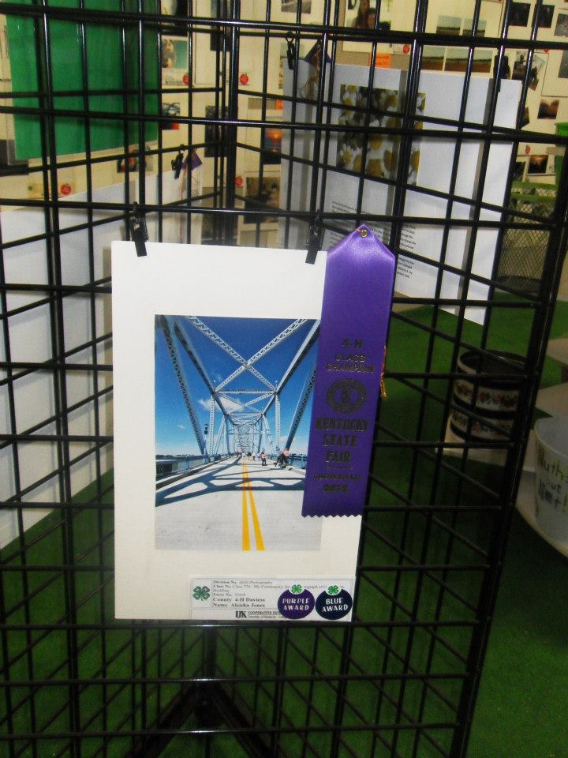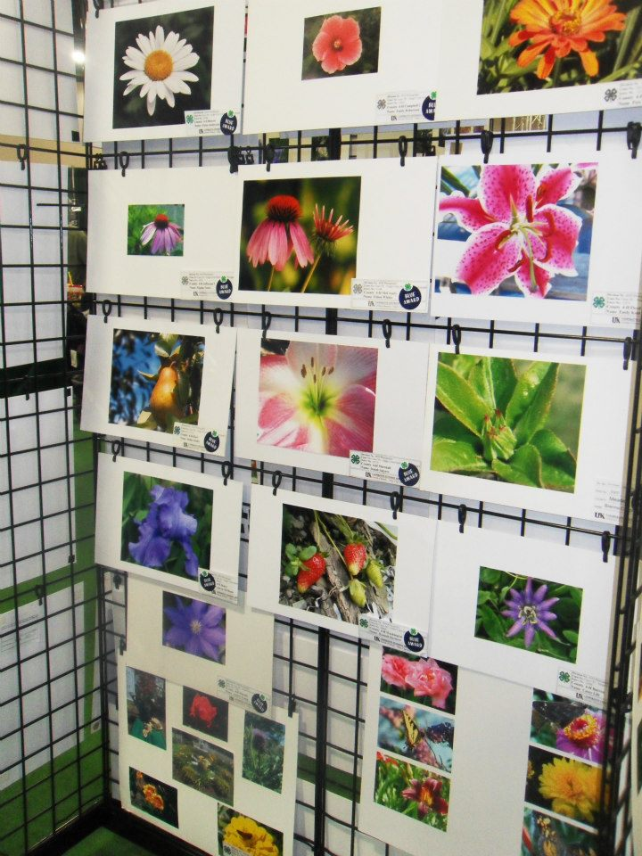

**Awards in each class:**

**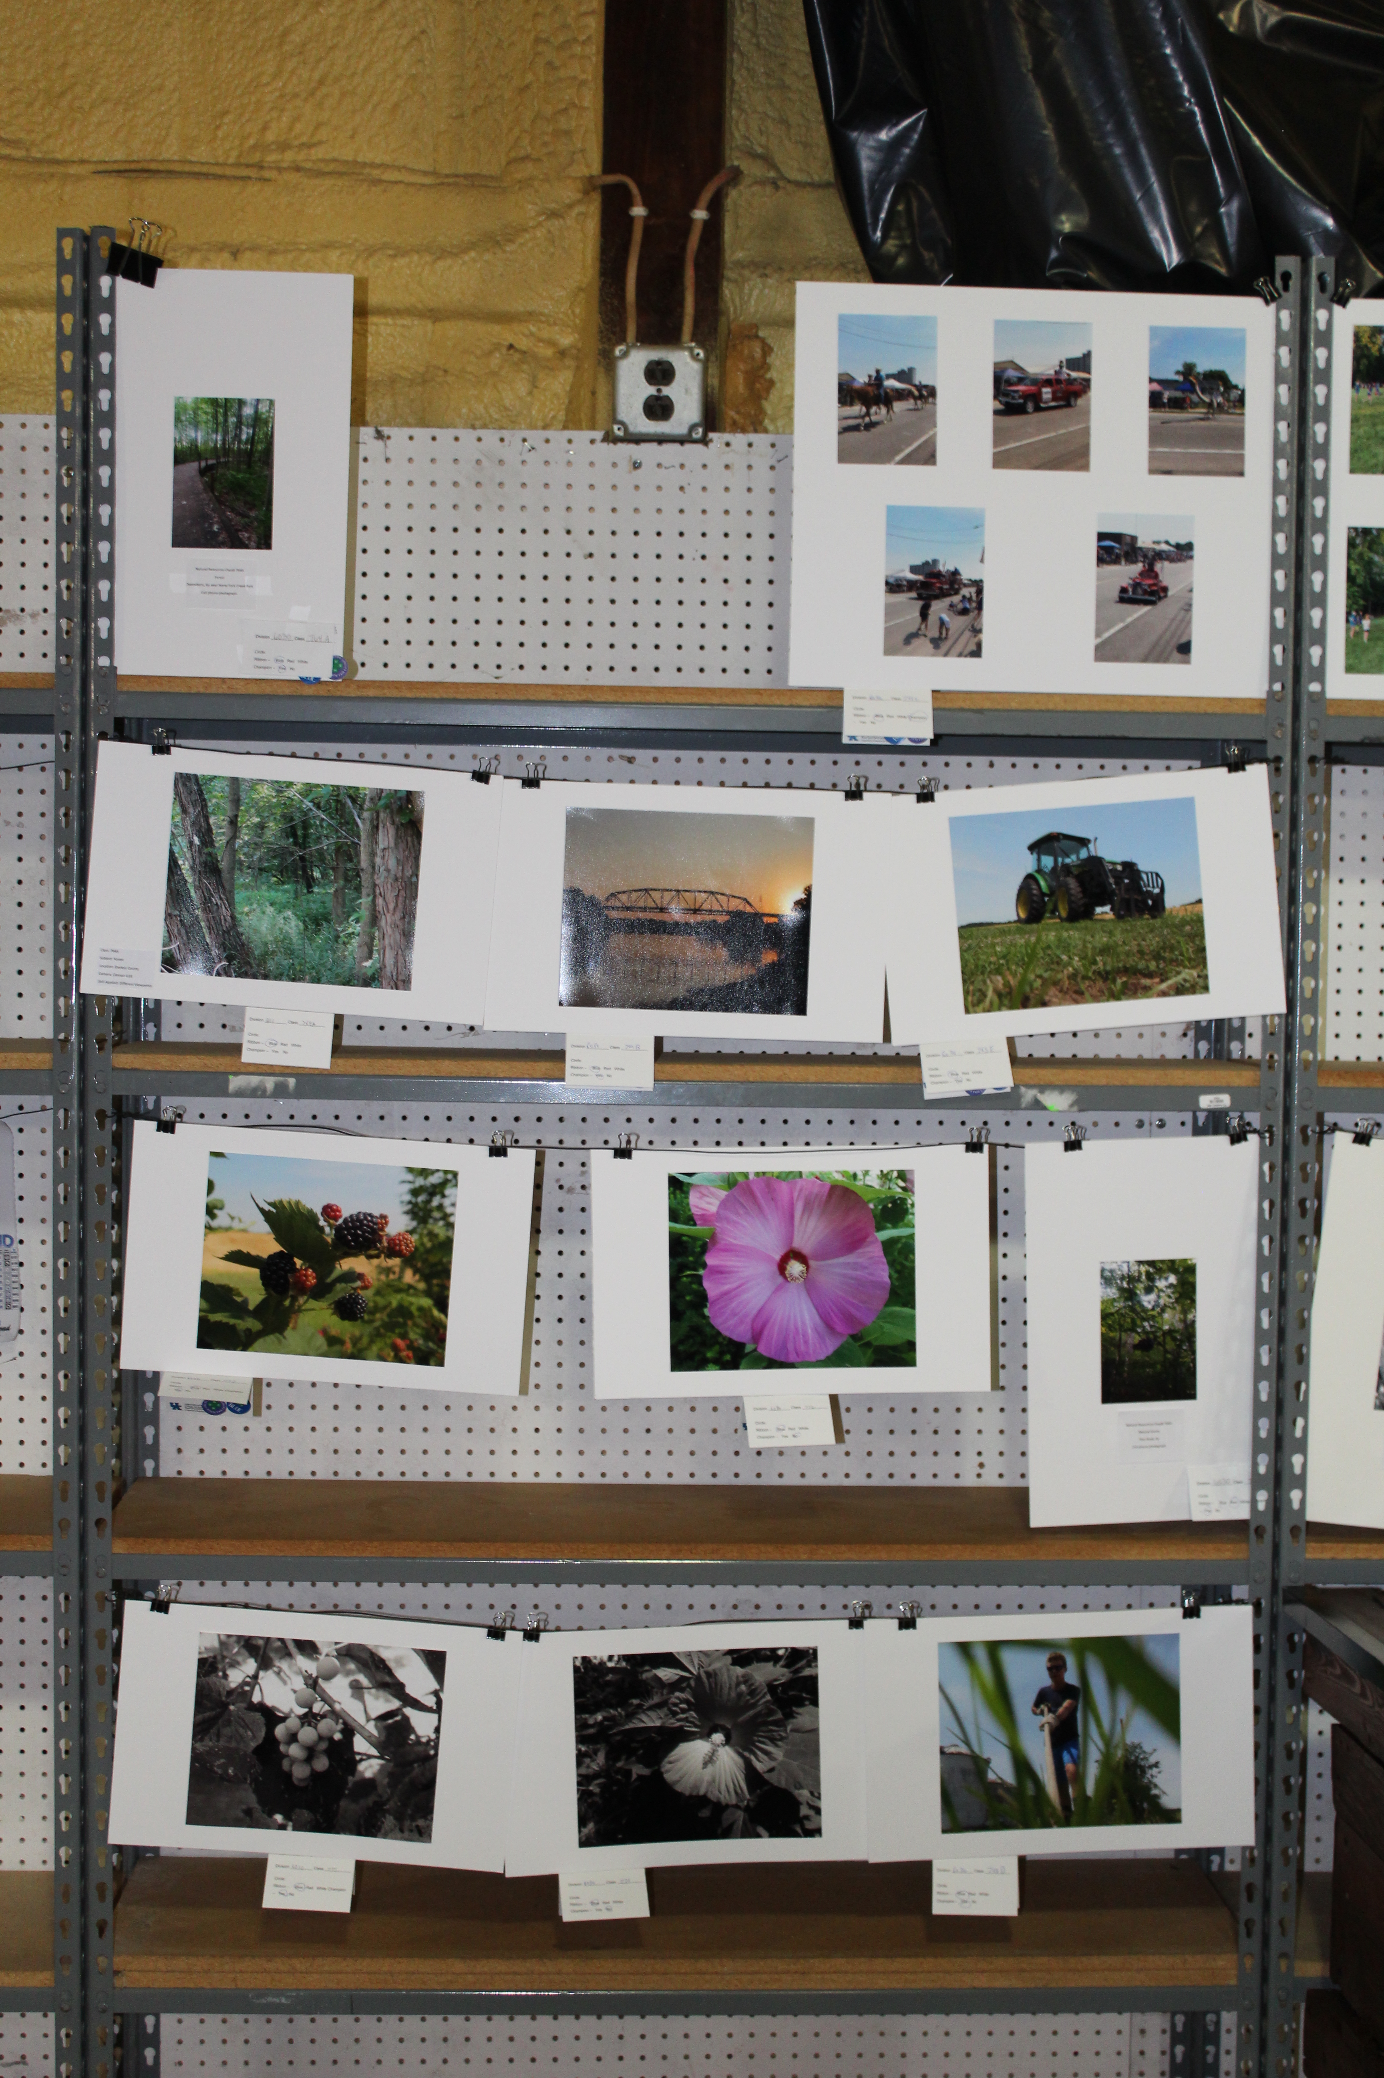  
1ST $10.00  
2ND $8.00  
3RD $6.00**

**DIVISION 4004 –PHOTOGRAPHY**

* This division is for intermediate and novice photographers. For purposes of this fair competition, you are considered qualified if you have never entered before or have won a blue ribbon but do not sell photographs. **No Professional photographers.** Entrants must abide by all entry rules of the Photography Divisions.
* Each entrant is permitted one entry only in each class. Photographs may not duplicate an image used in any other class (i.e. color to monochrome). Duplicates will be eliminated from the competition.
* All photographs must be the artist’s original work (with the exception of the actual printing).

**MONOCHROME (BLACK & WHITE OR TONED, INCLUDING SEPIA)**

|  |  |
| --- | --- |
| **CLASS** | **DESCRIPTION** |
| 60 | PEOPLE and/or ANIMALS – Two or more subjects depicted in posed or candid compositions. *The subjects must be people and/or animals.* |
| 61 | PLACES – The subject of the photo can be any local or global place. The tag must name the photographed location. Can include scenic, natural landmarks, and urban environments. *People/animals may be in the photograph but not portrayed as the main subject.* |
| 62 | THINGS (Digital Art) – Grouped arrangements of objects, collectibles, still life, or other “stuff”. Use interior lighting or best use (window) natural lighting. No pets or people. Can include books, art, toys, tables, food, tools, furniture, etc. |

**COLOR**

|  |  |
| --- | --- |
| **CLASS** | **DESCRIPTION** |
| 70 | PEOPLE and/or ANIMALS – Two or more subjects depicted in posed or candid compositions. *The subjects must be people and/or animals.* |
| 71 | PLACES – The subject of the photo can be any local or global place. The tag must name the photographed location. Can include scenic, natural landmarks, and urban environments. *People/animals may be in the photograph but not portrayed as the main subject.* |
| 72 | THINGS (Digital Art) – Grouped arrangements of objects, collectibles, still life, or other “stuff”. Use interior lighting or best use (window) natural lighting. No pets or people. Can include books, art, toys, tables, food, tools, furniture, etc. |